**Steps to install**

1. Install Virtual Box by clicking on VirtualBox-4.3.24-98716-Win.exe
2. Copy "ClouderaVM" to any drive
3. Open Oracle VM Virtual Box
4. Click on New. Enter the details as shown in screenshot.

Name: Cloudera, Type: Linux, Version: Ubuntu 64bit

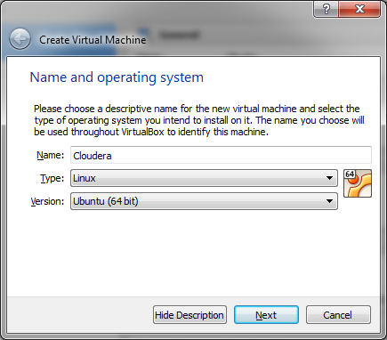

1. Memory Size – Set to 1.8GB
2. Hard drive- choose "use an existing virtual hard drive" and set the location to "ClouderaVM" folder on your hard drive

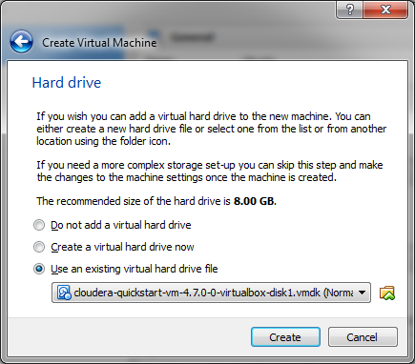

1. Click on "Create"
2. To open Cloudera Manager user:cloudera , password:cloudera